**Document upload Guidelines for JU CAS Portal**

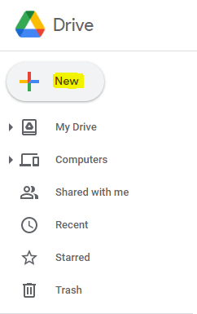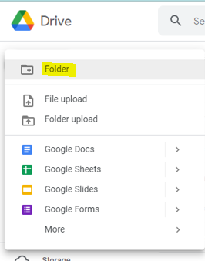

Click **New** in your Google Drive account and select the **Folder** option

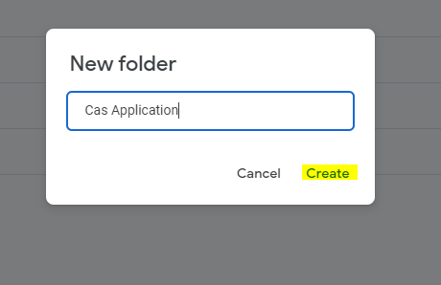

Give a name to your folder and click **Create** option. A new folder will be created where you can store the files as attachments.

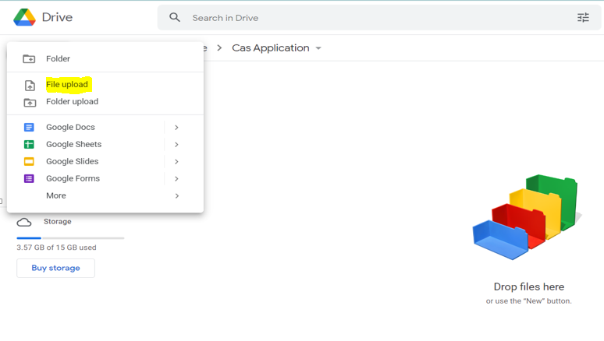

You can either drag and drop the files or use **File upload** option by clicking the **New** button

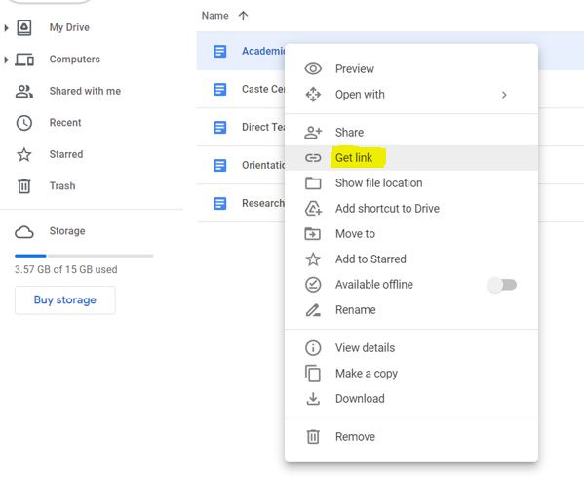

To copy the document link, right click on any attachment and select **Get link** option

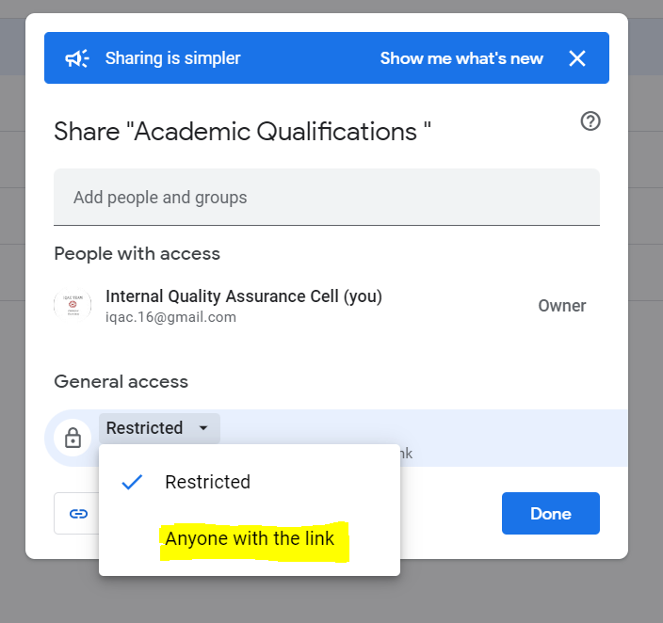

Select the option **Anyone with the link** in General access category

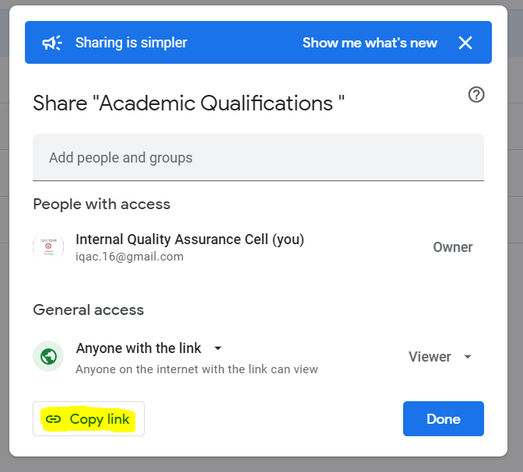

Click the **Copy link** option and you can paste this link in the Document Link tab of CAS portal.